29.18: a) With current passing from 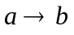and is increasing the magnetic, field becomes stronger to the left, so the induced field points right, and the induced current must flow from right to left through the resistor.
b) If the current passes from 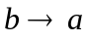, and is decreasing, then there is less magnetic field pointing right, so the induced field points right, and the induced current must flow from right to left through the resistor.
c) If the current passes from 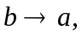 and is increasing, then there is more magnetic field pointing right, so the induced field points left, and the induced current must flow from left to right through the resistor.

